**Viewing Site Contents on OneDrive**

1. From the HuB homepage, select **OneDrive.**

1

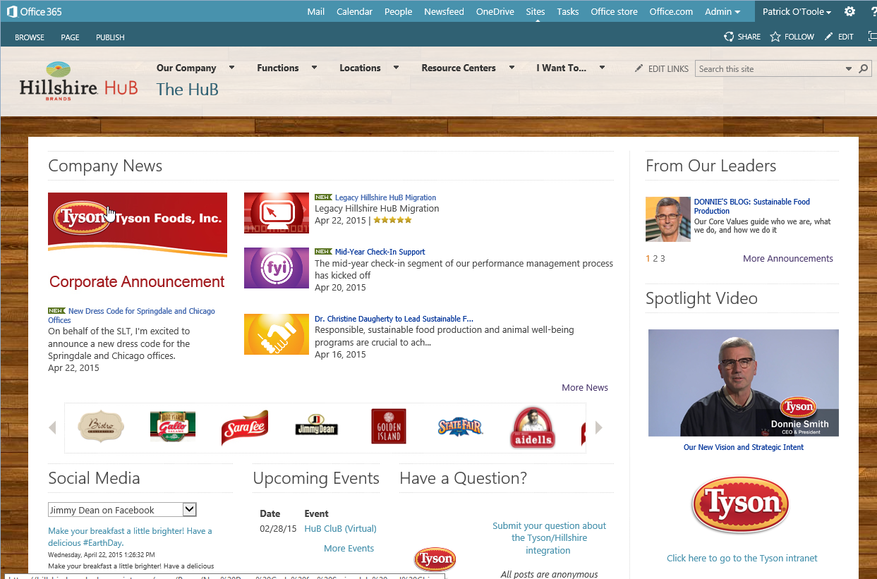

1. On your OneDrive page, select the gear (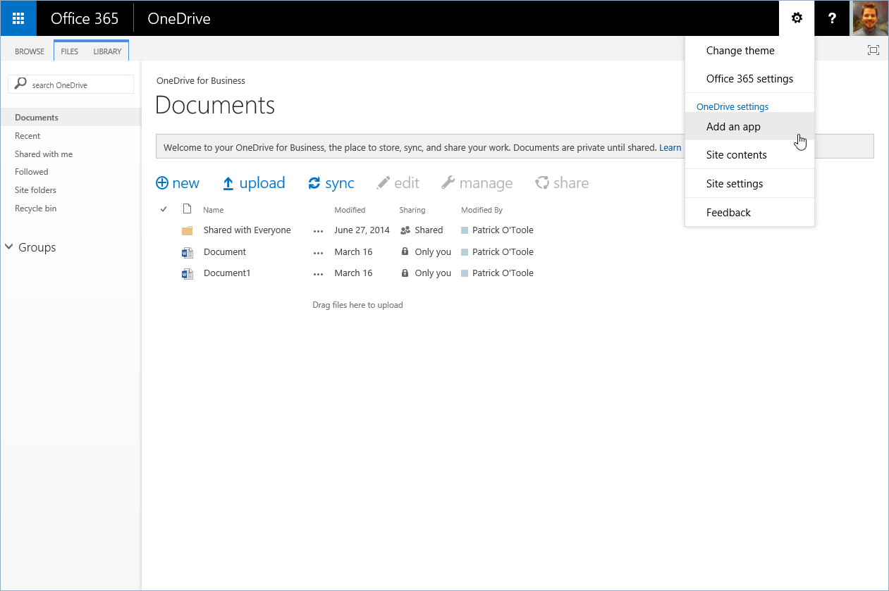).

2

1. From the dropdown menu, select **Site contents.**

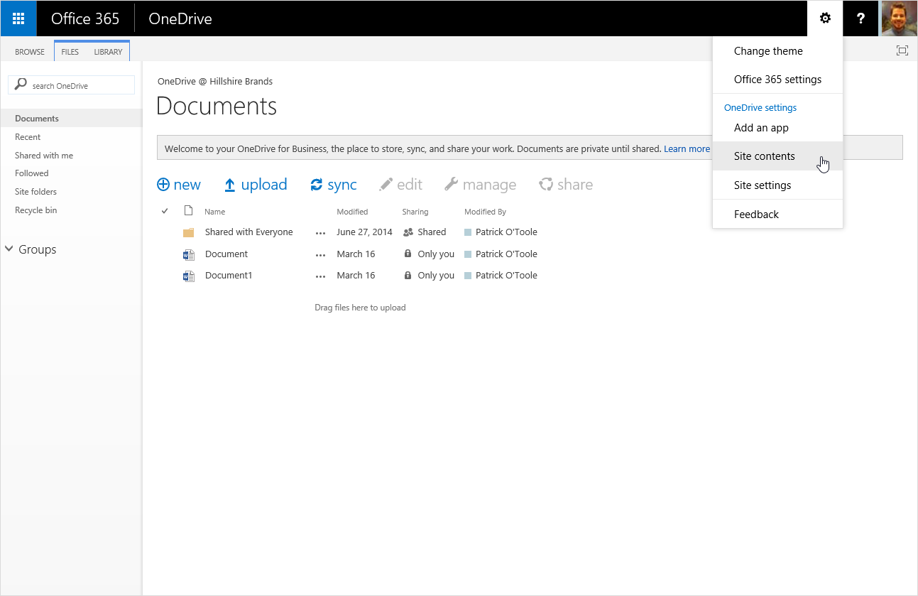

3

1. The site contents page will be displayed.
2. Additional libraries will show up under **Shared Documents, Personal Documents, and Shared Pictures.** ***Any content in these sections will not be migrated.***
3. Additional sites will show up under **Subsites**. ***Any content in this section will not be migrated.***

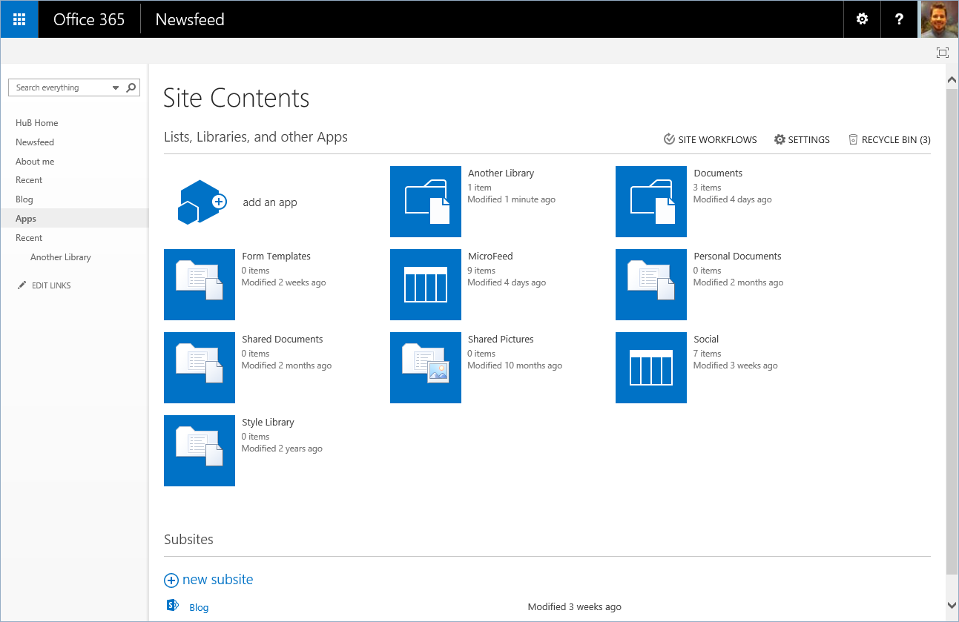

5

5

5

6

4